VISIT TO THE KAAS PLATEAU AND THE NAOROGI GODREJ CENTER FOR PLANT RESARCH (NGCPR) – SATARA
Pre- Field trip activity:
A field trip was arranged for Second Year and Third year students of Botany (Academic year 2018-2019) to Kaas Plateau, Satara and Naoroji Godrej Center for Plant Reserach, Shindewadi, Maharashtra on 21st and 22nd September 2018. Twenty one students and 2 Faculty members of Botany department went for the field trip. This initiative was taken by the Botany department to enlighten the students of Botany regarding the importance of biodiversity at Kaas plateau and the latest research in plants at NGCPR. It would definitely provide students with the knowledge of what career they can opt for after graduation/ Post graduation.
Pre- activities:
1. Meetings with the students on how to prepare themselves for the field trip.
2. The do’s and dont’s during the field visit.
3. Discussion with the students about the travel fare and staying facilities at Satara.
4. The students were given an activity wherein they had to find out information about the places they were going to visit at Satara and submit their report on Google Classroom page.
Source: Snapshot of the Google Classroom page – Field trip to Satara, showing the submission of pre activity report.
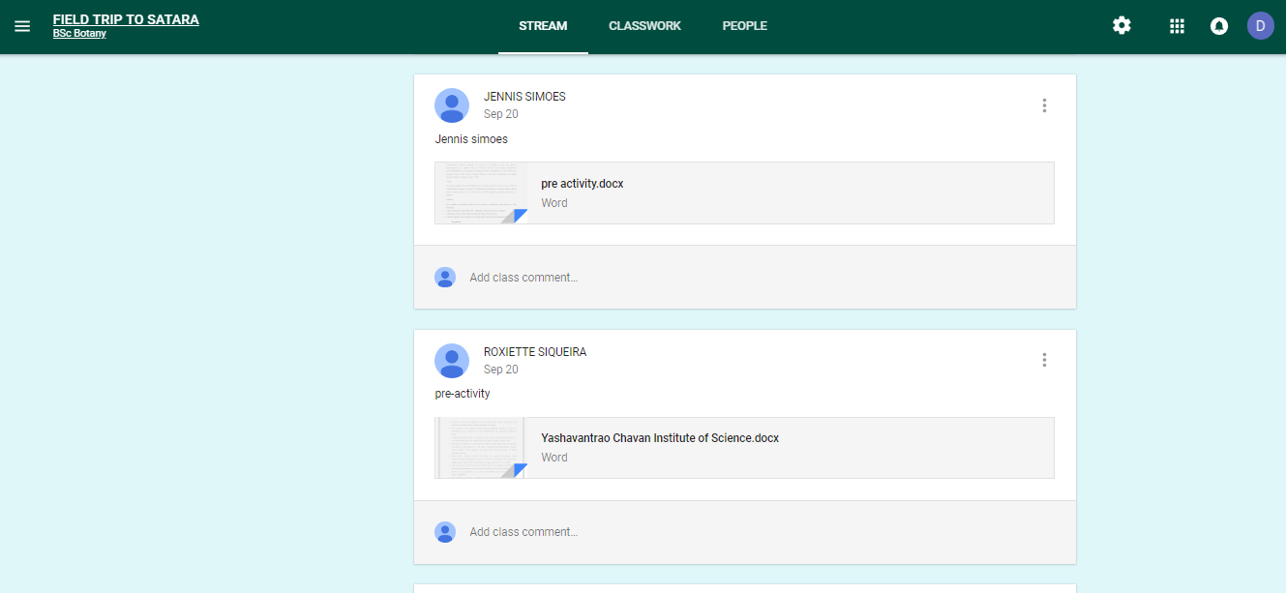
Source: Snapshot of the Google Classroom page – Field trip to Satara, showing the submission of pre activity report.
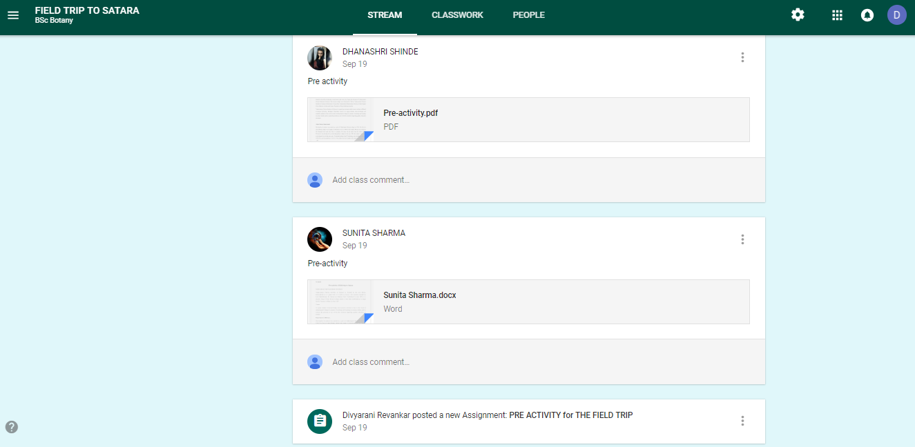
Source link: https://classroom.google.com/c/MTcwMjA0NjU5OTJa
Classroom code: hl3y6yb
Post field trip activity: Students after coming back from the field trip submitted field trip report. The report was assessed by Dr. Uma Masur.
FIELD TRIP REPORT

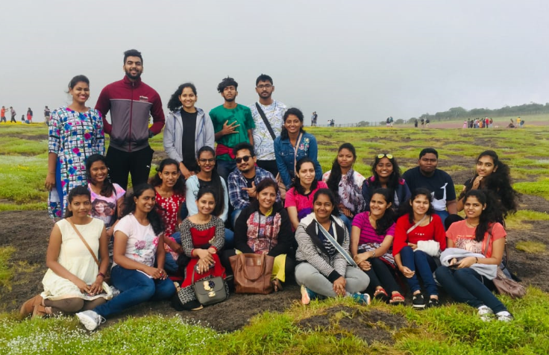
Team of Botany Department of Parvatibai Chowgule College

The Department of Botany of Parvatibai Chowgule College had organised a field trip to the Kas Plateau (Kas Pathar) which is located in Satara (Maharashtra) on 21 and 22 of September 2018. The visit to the Kaas plateau was conducted for the students to expand their knowledge about the plant species found in this region and also for studying and identifying the various endemic and endangered plants found in this area only. It was a very informative and knowledgeable for the students.
Visit to the plateau:The Kaas Plateau, also known as the Kaas Pathar or Kas Sadas, is a plateau situated 25 kilometres West from Satara city in Maharashtra, India. It falls under the Sahyadri Sub Cluster of the Western Ghats, and it became a part of a UNESCO World Natural Heritage Site in 2012. It is a biodiversity hotspot known for various types of seasonal wild flowers bloom and numerous species of endemic butterflies occurring annually in the months of August and September. The plateau is situated at an altitude of 1200 metres and is approximately 10 square kilometres in area. More than 850 species of flowering plants are reported on the plateau, from which 624 species have entered in the Red Data Book and out of these 624 species, 39 are found only in Kas Region.These include orchids, shrubs such as the Karvy, and carnivorous plants such as Drosera indica, etc. Kaas Pathar is a plateau made from volcanic rocks in the Satara district of Maharashtra, and comes under the biosphere of the Western Ghats. The plateau is largely formed of basalt which is directly exposed to atmosphere.The basalt is almost covered entirely by a thin cover of soil formed due to erosion and has accumulated a layer of not more than an inch or so. And thus the floras of these region are endemic. Kas Lake is on the south of the Kaas Plateau and is surrounded by dense forest. It lies between Sajjangad fort and the Kanher Dam.
The climatic conditions at the plateau was humid, cold. This conditions was very much favourable for the plants growing this region. The plateau is spread through 1792 hectares of area, latitude is 17⁰ 42’ to 17⁰ 45’ and longitude is 73⁰ 47’ to 17⁰ 56’, medium humidity, it has lateritic soil. They found that the plateau was dominated by the species of Eriocaulon,Impatiens and Smithia.
Western Ghats are not true mountains but are the faultered edge of the Deccan plateau. They are globally recognised as the global important region for conservation of biological diversity. It is believed to be formed about 150 million years ago during the breakup of super continent Gondwana. It is the located in India and is spread from Gujarat, Maharashtra, Goa, Karnataka, Kerala and Tamil Nadu. The soil type is laterite soil. Kas plateau is the part of the Western Ghats located at Satara-Maharashtra. The Kas plateau is known for its endemic and endangered flowering plants.

Flowers observed:
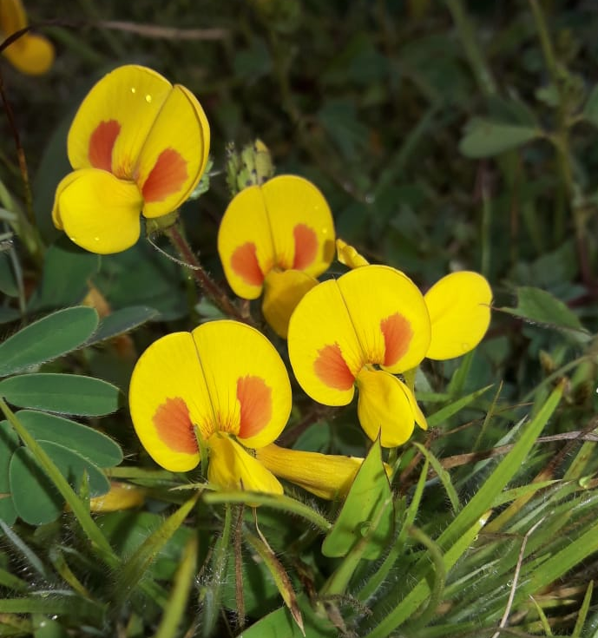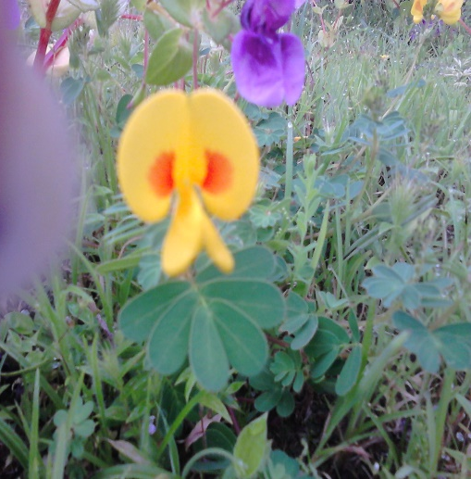

Smithia bigemina Smithia hirsuta
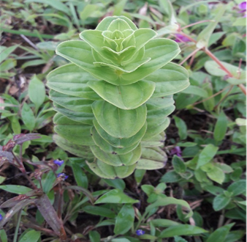
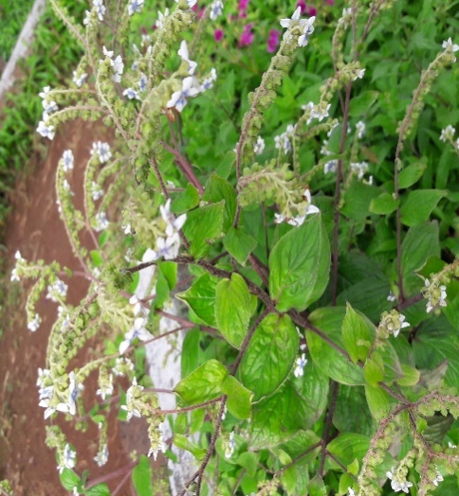

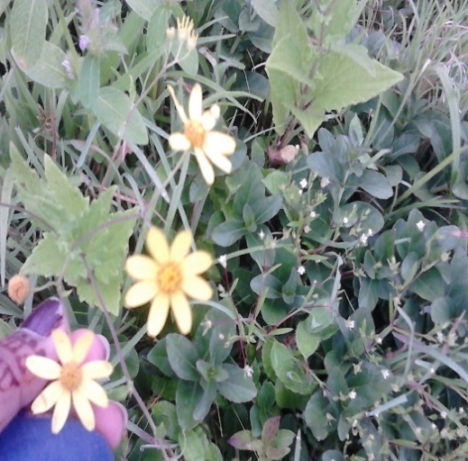
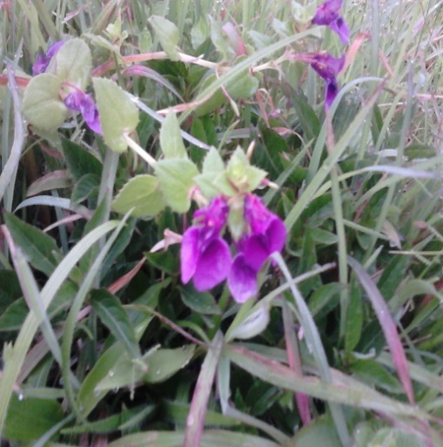

Senecio bombyensi Impatiens sp.

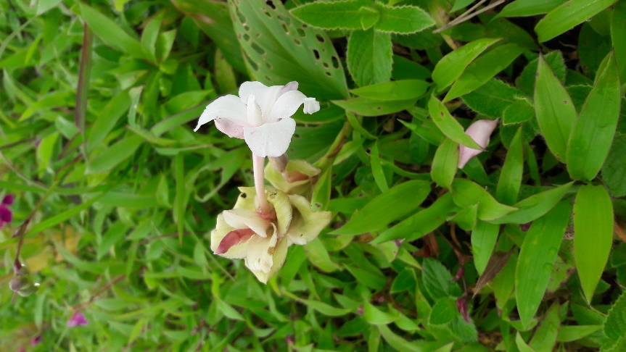

Zingebaraceae sp. Ramphicarpa longiflora

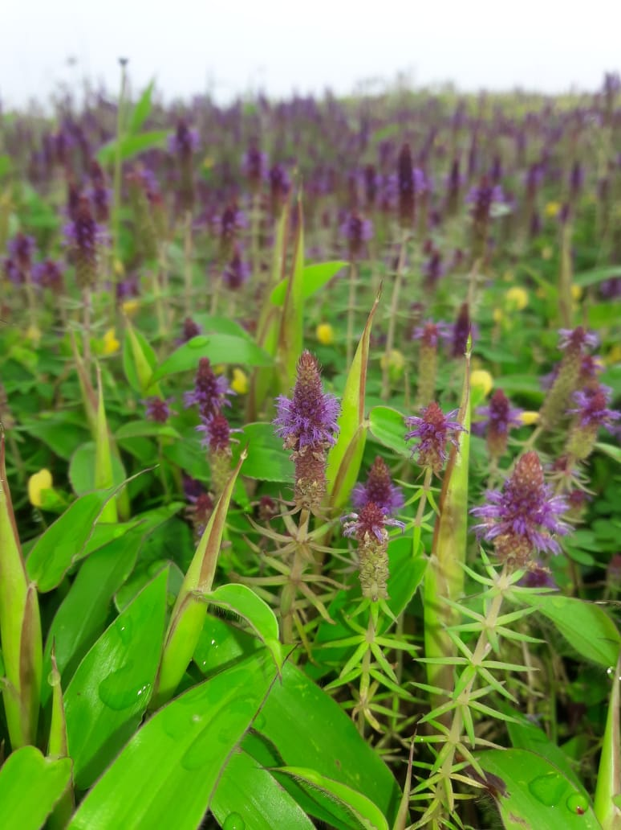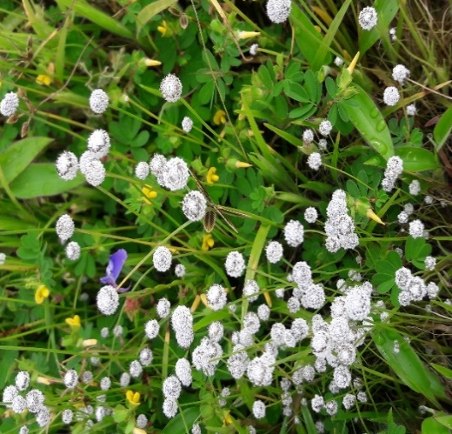
Pogostemon deccanensis Eriocaulon sedgewickii

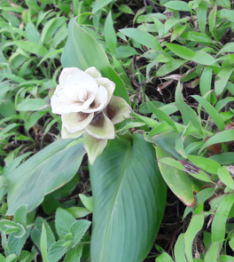

Impatiens sp.

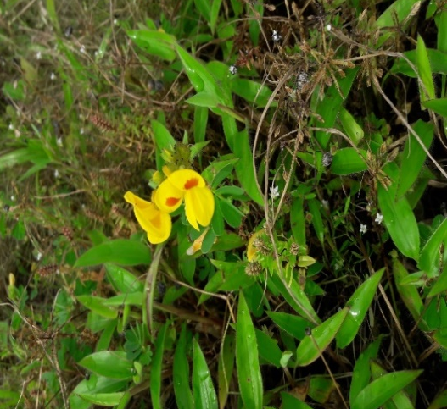
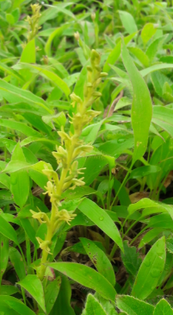

Peristylus densus Smithia bigemina
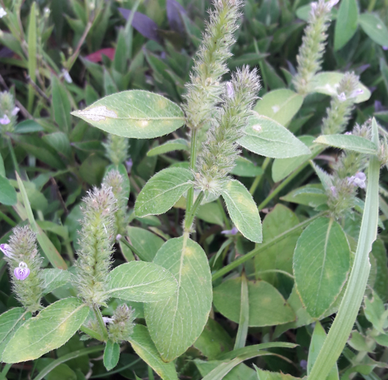

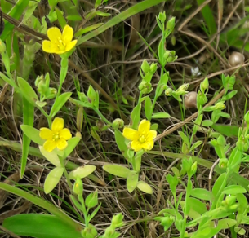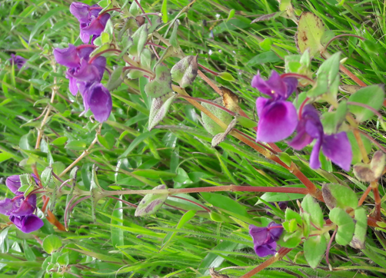

Linum mysurense Impatiens sp.

Impatiens sp. Impatiens lawii

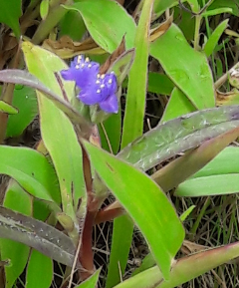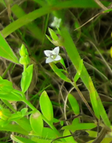

Murdannia simplex Hedyotis diffusa

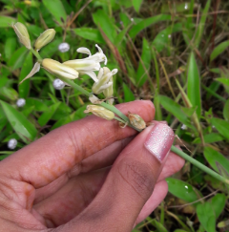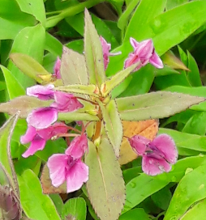
Dipcadi montanum Impatiens balsamina

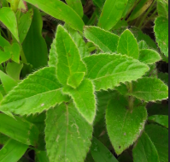
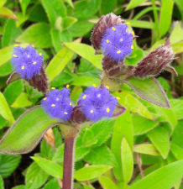
Murdannia lanuginosa Cynotis tuberosa

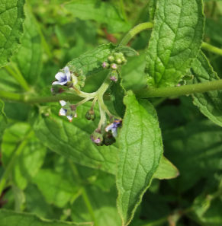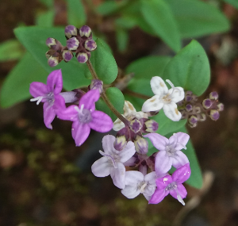

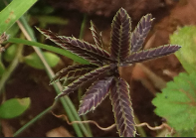

Amboli Ghat: On the way to Satara the famous Ghats of Amboli made the mind fresh and the waterfall is very beautiful. The mountains were covered with the greenery and has a rich diversity of plants. The environment was cold and refreshing.
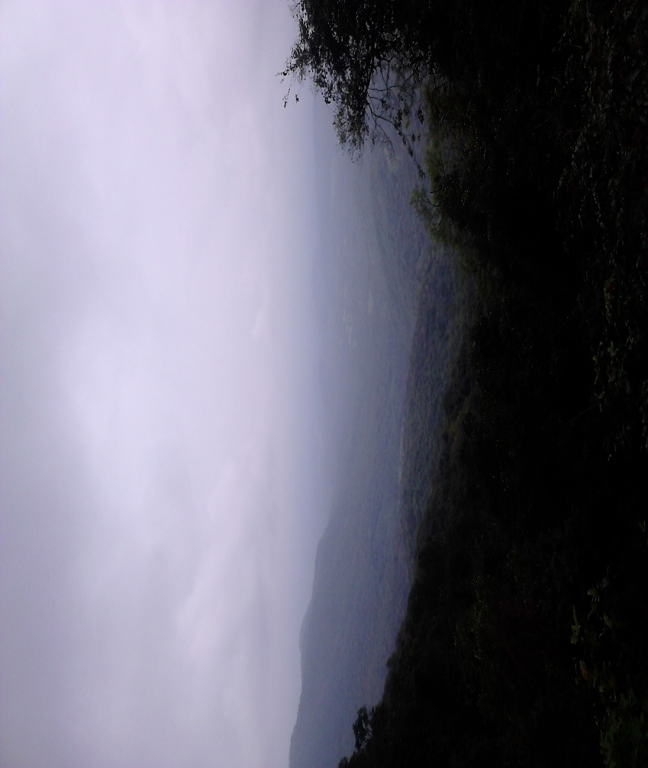
Ghats of Amboli on the way to Satara
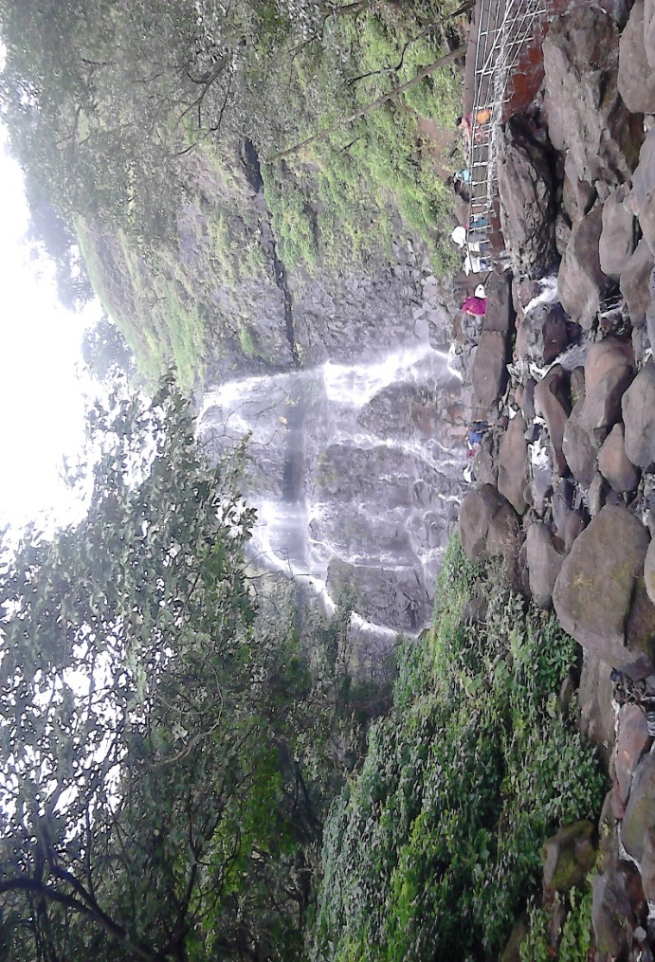
Amboli Ghat waterfall

Visit to Naoroji Godrej Centrefor Plant Research (NGCPR):
Named in fond memory of Late Shri Naoroji Godrej.The Naoroji Godrej Centre for Plant Research (NGCPR) was established in the year 1992 as a Section 25 Company for non-profit objectives - its objective was to carry out purposeful research in the areas of Plant biodiversity & conservation. The Centre is also recognized by The Department of Scientific & Industrial Research (DSIR) of the Government of India, to conduct need-based research in Biodiversity & Plant conservation, with particular emphasis on nurturing and propagating unique plant life of the Western Ghats and Medicinal plants that are of national interest.
Their vision is to carry out purposeful research in Plant Biodiversity and Conservation with special reference to Endangered and Threatened species of medicinal plants endemic to the Western Ghats.
They have major collaboration with the Savitribai Phule University, Pune; Shivaji University, Kolhapur; Foundation of Medical Research, Mumbai and Botanical Survey of India, Western Circle, Pune.
Have a journal where all the researches and work is published - Journal of Threatened Taxa, and the website - www.threatenedtaxa.org
Recently the centre is working on the taxonomy of the plants in the Western Ghats, and on conservation and expansion of the endangered and some endemic species of Western Ghats which are equally economically important pants.
Some of the plants on which this centre is working are: Chystelma naorojii, Arapaima murrayi, Commelina badamica, Impatiens acaulis, Jasminum malabaricum, Habenaria panchaganiensis, Cochlospermum religiosum,etc. They are also working for conservation of the two globally endangered species viz. Frerea indica Dalzell (Apocynaceae) and Abutilon ranadei (Malvaceae).
They have been working towards the conservation of sacred grove where they identified 14 sacred groves in the Parinche valley, in Pune district. Secondly they have also contributed towards the afforestation and regeneration of 125 hectares of land in Palshi and Mirje villages.
They conducted the trade studies on medicinal plant studies like Nothapodytes nimmoniana and Terminalia chebula.

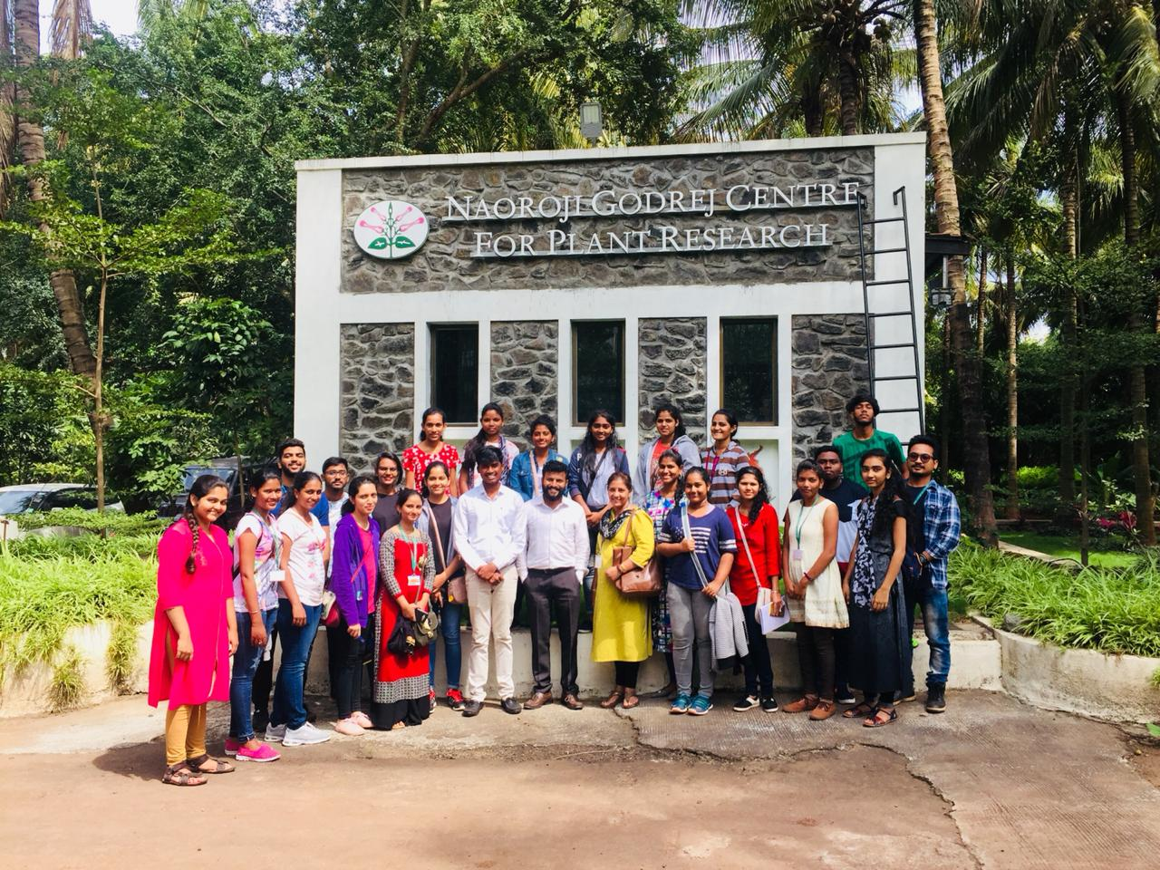
The group of students and teachers visited NGCPR with Dr. Mayur D. Nandikar

Some of the medicinal and important plants grown at NGCPR:

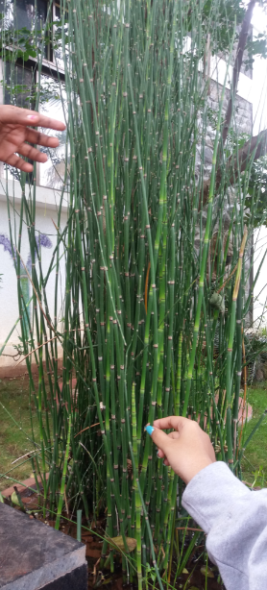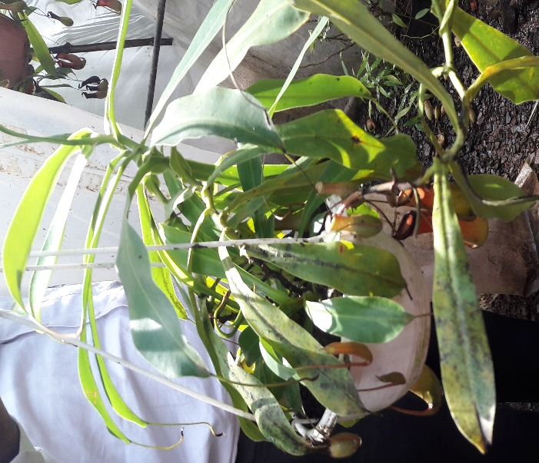
Equisetum sp. Pitcher plant at the NGCPR centre

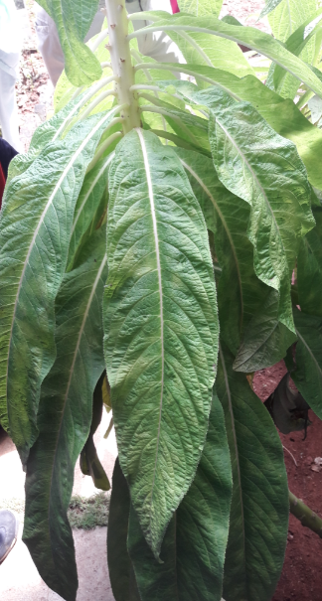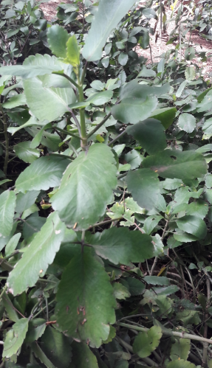

Altogether the trip was a great experience which was full of knowledge and was very informative. This trip has realised us the importance of the plants in the Western Ghats – Kaas plateau and their nature and the environment where they are found, which makes them endemic to that region only.

